Name ____________________________________________ Date _________________ Per _____
An Epitaph for Sam McGee
Your goal is to write an epitaph for the character Sam McGee. Epitaphs are short poems which mourn a person who has died. Often epitaphs were placed on the person’s tombstone. Epitaphs are meant to be serious, however it is possible these poems to be funny in an effort to make a point or to catch a viewer’s attention.
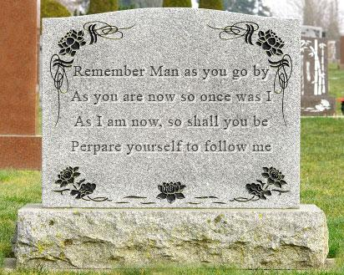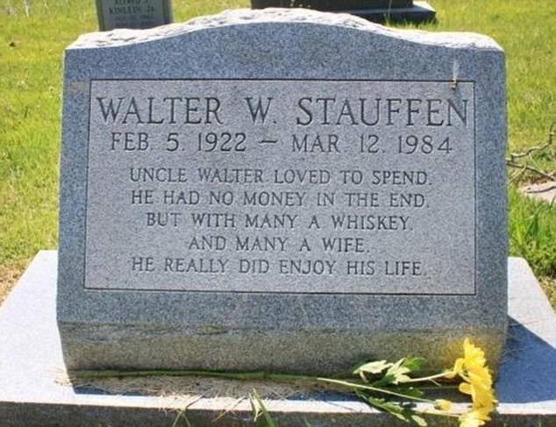
Epitaphs are usually only four lines in length with a rhyme scheme of AABB but can be altered to ABAB
The first line of your epitaph is done…you add the rest but be sure to use evidence from the text to include in this short poem. Make use you follow the rhyming pattern.

Here are the ashes of Sam McGee A

___________________________________________________________________________ A

____________________________________________________________________________ B

____________________________________________________________________________ B

Type your completed epitaph in the text box on the back of this page. Be sure to follow poetic rules of construction.

